Chapter 7, Problem 88.

The circuit in Fig. 7.148(a) can be designed as an approximate differentiator or an integrator, depending on whether the output is taken across the resistor or the capacitor, and also on the time constant ι = RC of the circuit and the width T of the input pulse in Fig. 7.148(b). The circuit is a differentiator if 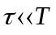, say
ι < 0.1 T, or an integrator if 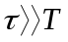 T$, say ι > 10 T.

(a) What is the minimum pulse width that will allow a differentiator output to appear across the capacitor?

(b) If the output is to be an integrated form of the input, what is the maximum value the pulse width can assume?

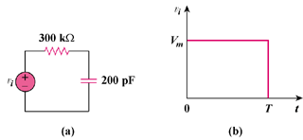

Figure 7.148
For Prob. 7.88.

